School of Information Technology
Diploma in InfoComm and Security

ITP271
WEB APPLICATION
DEVELOPMENT & PROJECT
Academic Year 2019 Semester 1

Project Guidebook for Student
UNCONTROLLED COPY

TABLE OF CONTENTS
- Introduction 2
- Module Information 2
  - Aim
  - Objectives
  - Learning Outcome
  - Teaching, Learning and Assessment
- Project Approach 4
- Project Organisation 5
- Project Planning and Control 5
  - Project Plan
  - Project Control
  - Project File
  - Attending Review Sessions
- Project Deliverables and Presentation 7
  - Project Schedule and Deliverables
  - Documentation
  - Project Requirements
  - Task Assignment Examples
- Project Assessment 9
  - Assessment Components
  - Assessment Criteria
8. Appendix
Appendix A – Project Schedule & Deliverables 10
Appendix B – Documentation Layout and Format 13
Appendix B.0 – Project Initiation Form
Appendix B.1 – Analysis & Synthesis Worksheet (Activity 1)
Appendix B.2 – Functional Specification (Activity 2)
Appendix B.3 – System Design Document (Activity 3)
Appendix B.4.1 – Website Evaluation Form (Activity 4)
Appendix B.4.2 – Project Test Plan (Activity 4)
Appendix B.5 – Final Project Report
Appendix C – Grading Guidelines and Rubic
Appendix C – Grading Guidelines 30

- INTRODUCTION

This module guide is intended to explain to you the operation, management and concepts of the Project component of this Module. In this guide you will find information and advice on a number of important aspects of the project in terms of what is required from you and your team, what you can expect from the module and how it is operated and administered.

The project provides a framework for you to demonstrate skills and knowledge acquired to-date in your diploma programme. This is achieved through teamwork aimed at producing a solution for an online business opportunity.

You are strongly encouraged to make backup copies of source codes and documentation at the end of the semester. In the event of loss data, the team will bear the cost of the losses, by putting in extra hours to re-code the project.

It is unlikely that the guide will provide answers to all possible questions; therefore it is vital that you remain in regular contact with your supervisors. This will enable them to keep a check on progress and provide advice on problems arising during the project in the contact sessions. You need to take initiative to troubleshoot the technical problems by reading from reference books or through search engine via the Internet links. The Module Leader should be advised of any organisational problems as soon as possible.

- MODULE INFORMATION

Module Code: ITP271
Module Name: Web Application Development & Project
Stage: 2
Hours: 120 hrs

2.1 Aims
- To allow students to apply knowledge and skills learnt in the other modules, to design and implement a Business solution to a real world business problem.
- To expose students the soft skills of Project Management and Team Work.

2.2 Objectives
To develop an innovative and practical business application by applying knowledge learned in this and other modules.
2.3 Learning Outcome
Upon completion of this project module, you would have acquired the following knowledge/experience:

  - To plan and manage a project
  - To work in team effectively
  - To apple knowledge and skills learnt in the analysis, design and development of an business solution
  - To evaluate and utilise the relevant internet tools and techniques to implement an business solution
  - To communicate effectively as a group as well as individually

2.4 Teaching, Learning and Assessment

Learning Strategy - Supervision: 90 hours
Independent Learning: 30 hours

- PROJECT APPROACH

The project is organised into 4 phases:

  - Project Initiation, Idea Generation and requirements gathering
- Project team formation, understanding of project scope and expectation and project requirement clarification.
- Idea Generation, brainstorming and information gathering via Design Thinking.
- Project proposal writing.

  - Analysis & Design
Formulate conceptual and system design based on proposal.

  - Development, Integration & Testing
Develop product based on design, coding, and integration and testing

  - Acceptance Testing, Deployment & Maintenance
Conduct Acceptance Testing, deploy application and undertake maintenance.

- PROJECT ORGANISATION

The students will form into project teams. Each project team comprises of 3 students (maximum 4) and to be supervised by a supervisor. (Members strictly within same module group) Each project team will elect a leader by its members.

a) Role of Group Leader
i) Lead the team to ensure that the team is complying with the Project Guidebook and Project Specification.
ii) Coordinate and assign work among members.
iii) Monitor and update progress of project.
iv) Liaise with the project supervisor on the progress of the team, including the booking of meeting venues (if necessary).

b) Role of Group Members
i) Complete the allocated tasks. Marks will be deducted against an individual, if he/she needs to rely heavily on others to complete his/her tasks. The purpose of this requirement is to cultivate independence of individual member.
ii) Cooperate with the rest of the team to develop and implement the allocated application system.

c) Role of Project Supervisor
i) Act as an adviser. If necessary, provide advice on project management, project scope and project deliverables.
- Monitor the progress of the teams.
- Act as management/users/customers.

- PROJECT PLANNING AND CONTROL

5.1 Project Plan
Each team (led by the team leader) is required to distribute workload evenly among members. Each team must produce a project schedule plan, with the detailed tasks assignments indicated clearly as the project progresses. Students’ individual performance is assessed based on individual tasks assignment.

  - Project Control
Milestones are a mechanism to monitor progress. At each milestone, there is deliverable item to be submitted. Normally a contact session with supervisor is arranged for every milestone check. One of the team leader’s duties is to monitor the progress of the team and seek appropriate help. Team leaders if necessary can arrange extra meeting sessions with supervisors.

5.3 Project File
Each team is strongly recommended to maintain a team project file to keep all working documents, which relate to the project. Each member should maintain individual project file to keep all individual working documents. Both project files should be brought along to the supervision sessions, and later to the formal reviews. Items that might be held in the file are:

- Project management aids such as schedule, Gantt charts etc.
- Diary of work giving date, time, place and duration of activities
- Research literature and notes
- Interview notes and correspondence, minutes of meetings
- Draft report
- Deliverables etc.

5.4 Attending Review Sessions

Each team MUST maintain regular contact with its supervisor according to the allocated laboratory and tutorial hours. These sessions are compulsory as they present an opportunity for the team to seek advice and guidance from the supervisor.

The purpose of the review is to assess the progress of the project, and the team’s ability to manage the project as a whole. It is also an opportunity for the supervisors to give feedback to increase the chances of success.



- PROJECT DELIVERABLES AND PRESENTATION

  - Project Schedule and Deliverables
Refer to Project Schedule & Deliverables (Appendix A).

  - Documentation
    - Project Proposal Document (Appendix B.1)
    - System Design Document (Appendix B.2)
    - Project Report (Appendix B.3)

  - Project Requirements
The implemented website should have the following requirements:
      - Technical Requirements
The following technologies & techniques to be applied:
- ADO.NET for database access
- Web Site Design using Master Pages, Site Navigation, CSS, Bootstrap, Web Site security
- Security Features and State Management
- Error handling techniques using Try/Catch & Validation Controls

      - Functional Requirements
Based on the proposed prototype， the following functional requirements must be met:
- Part 1 –
  - Home Page with index access to other sections and pages
  - Description of web site
  - Membership registration
  - Membership Search and Editing/Modification
\
- Part 2 –
  - Allow creation of data (Input form) - this is based on your project’s purpose and functionality
  - Retrieval and display of images web site (not hardcoded)
  - Search functions based on 1 or more search criteria provided by the user.

- Part 3 – Login and Security
  - Login and Logout features,
  - Password and login details kept in database
  - Sessions Incorporated
Each individual must implement at least 1 of the above features with CRUD functionality covering the perspective from a member/customer to the administrator
.
      - Enhanced requirements
For Teams which have met basic requirements specified in (a) and (b), they are strongly encouraged to implement enhance features using the following examples. The list is not exhaustive. You are free to propose your own. However, it is up to the Tutor’s discretion whether these requirements implemented are substantial enough to justify for better grades:
- Internationalization (Support multiple languages)
- Location sensitive features (Google map, Bing Map)
- Security Features (OTP, Injection Prevention, Hiding URL)
- Cloud Technologies (Windows Azure or equivalent)
- Web Services (Utilizing data.gov.sg)
- Object Oriented Programming (using classes)
- Support other security features (Eg. Captcha, encryption, IC verification algorithm, facial recognition, thumbprint, etc)
- Any other technologies - Using SMS/Email/QR Code

  - Task Assignment Examples (Suggested Implementable Features):
Example 1 - Bargain Hunter Portal
Student A | Student B | Student C
New member registration module  - New member form  - New Member Notification  - Password and validation  Welcome Page module-  - Ad rotator  - Suggested products – Whats Hot  - Top 3 product shown (based on sales amount)  - Discounted products display | Shopping module that allows  - Product search with multiple filters of categories  - Shopping Cart for multiple quantities. Allow update or delete of items  - Display product status, sold out or discounted items  - Integrated to Paypal  - Ajax feature to prevent whole page reloading | Login Security module  - Login / Logout sessions  - Menu customised to guest, member or admin  - Password Verification  - Reset Password Facility  - Feedback Form  - Password Encryption/Decryption  - Captcha feature for authenticity verification  - SQL Injection Prevention
- Members can update own profile  - Admin can Search, Update, delete , Edit of members data  - Members can view pass transactions | Inventory Tracking  - List current item shipping status  - Administrator updates inventory status  Multi-language feature  Automatic Currency conversion | - Recommendation page which will recommend which product, based on member’s preference or passed transaction  - Cloud integration of database  - Latest Products News using WebService
- Mailing list  - QR code feature for Member Discounts | - Allow admin to Search, Update Inventory, Delete product, Input product Discounts | - Able to browse nearest shopping centre branch (Based on location) using data.gov.sg webservices
- SMS feature notification of discounts | - Google API translation feature | - Facial recognition login feature

- PROJECT ASSESSMENT (60%)
7.1 Assessment Components
The assessment of the module will have the following components, which are collated during the semester:
Component | Percentage | Group | Individual | Week - Deliverables | Grading Guidelines
 | 0 |  |  | Week 1 - Submit Project Initiation Form (Appendix B.0) | -
 | 5 | 1 | 4 | Week 4 – Analysis Worksheet (Appendix B.1) | Refer to Appendix C2
 | 5 | 1 | 4 | Week 5 - Functional Specification (Appendix B.2) | Refer to Appendix C2
Project | 5 | 1 | 4 | Week 8 - Database Design Document(Appendix B.3) | Refer to Appendix C2
Project | 10 | 8 | 2 | Week 12 - Progress Check 1 - Presentation | Refer to Appendix C1
Project | 10 |  | 10 | Week 15 - Progress Check 2 - Individual Technical Assessment | Refer to Appendix C3
Project | 20 | 5 | 20 | Week 17 - Final Presentation & Project Delivery | Refer to Appendix C1  Refer to Appendix C3
Project | 5 | 5 |  | Week 17 - Final Project Report Appendix B4.1, B4.2, b5 | Refer to Appendix C2
 | 60 | 20 | 40
 | 40 | The remaining 40% comes from practicals, tutorials, and a test between week 1 to 16

The assessment will be done jointly through:
    - Continuous assessment by supervisors throughout the duration of the project
    - Assessment by supervisor or independent markers (other lecturers) during the presentations
7.2 Assessment Criteria
7.2.1 Project Ideas and Presentation
- Originality and creativity of the ideas
- Ability to present and explain ideas and concepts
- Ability to explain implementations
- Ability to answer questions
7.2.2 Project Website
- Meets basic technical and functional requirements
- Web site ecstatically pleasing and consistent UI
- Proper database design
- Completed comprehensive system testing and deployment
- Implemented enhanced features
- Proper documentation (proposal, design document and final report)
7.2.3 Individual Technical Assessment
- Demonstrates knowledge and understanding of project
- Good programming practice

Please refer to Appendix C1,C2, C3 for more detail of the critera.
APPENDIX A – Project Schedule & Deliverables
Phase | Wk | Activity | Deliverables | Weightage %
Project Idea Generation & Requirements Gathering | 1 | Form Project TeamProject
Project Idea Generation & Requirements Gathering | 1  1  2-4  5 | Project Briefing  Research on existing problem challenge  Analyse and refine problem (using presented user feedback, cam study, surveys) and generate your solution  Define functionality of solution | Submit project initiation Form* by Week 4  Analysis Documentation* + Prototype Functional Specification* Submssion by end week 7 | 5%  5%
Analysis & Design | 6-8 | Work on design document | Submit preliminary design document* by end week 10 | 5%
Development, Testing & Documentation | 8- 16 | Coding & Testing
Development, Testing & Documentation | 12 | Progress Check 1 - Presentation | Group Presentation Week 12 | 10%
Development, Testing & Documentation | 15 | Progress Check 2 - Individual Assessment | Individual Assessment on Week 15 | 10%
Deployment & Documentation | 16 | Deploy web site. Documentation | Report Submission on week 16/17 | 5%
Project Submission | 17 | Project Submission, Project Presentation | Formal Presentation on week 17 | 20%

APPENDIX B.0 - Project Initiation Form & Activity 0
STEP 0 - Form your groups by Week 2 (Last Lab Session), print and submit the following form:
Document Title : Project Proposal Submission for an improved online shopping experience
Module Name : ITP271 Internet Application Development Project
Module Group : ___________________________
Project Team Name : ___________________________
Project Team No : ___ (To be assigned by Supervisor)
Team Leader : _________________________________
Team members :
S/No | Name | Admin No. | Internet Email/Contact number
1 | *
2
3
4
*Name of team leader to be in s/n 1
Submitted on: [Date]___________________________________
Human Centered Research + Creative Ideation (Analysis & Synthesis)
Activity 0 – Collaborative Research
STEP 1 – 30 mins
Group leader, form your collaborative group by registering with PADLET.com, then add
your group members. Create a new Padlet with the following title:
Padlet 1 - What are the current online shopping woes?
Each member should contribute 3 online shopping woes based on research.
After which put in 3 factors that contribute to a good and safe shopping experience. Hint – look also at user interface design, user friendliness, Service standards, Web Security, or any other issues etc
Show your tutor your group’s padlet dashboard once the exercise is completed.
STEP 2 - HOMEWORK:
Original Problem statement:
- The Management of Digitale Pte Ltd needs to improve the online shopping experience – particularly with improved User Functionalities & Better Web Security
Go through all the company’s user cam experiences and interviews (SEE BELOW ).
USER CAM EXPERIENCES (HYPERTHETICAL)
E-Commerce [Episode 1] - Messy User Interface | https://www.youtube.com/watch?v=NpIBNTwQPVk
E-Commerce [Episode 2] - Poor Color Choices | https://www.youtube.com/watch?v=Pqx4njqsitE
E-Commerce [Episode 3] - Simple HTML & CSS | https://www.youtube.com/watch?v=x3XV3IpcA4c
E-Commerce [Episode 4] - Detailed Categorisation | https://www.youtube.com/watch?v=nzbGJDStCKM
E-Commerce [Episode 5] - Price not shown | https://www.youtube.com/watch?v=n40A6UeiHtk
E-Commerce [Episode 6] - No Search bar | https://www.youtube.com/watch?v=C4AWAPpZx3E
E-Commerce [Episode 7] - Basic & Clear Categorisation | https://www.youtube.com/watch?v=g-YMCl_nTco
E-Commerce [Episode 8] - No language bar | https://www.youtube.com/watch?v=tk080C0J_9w
E-Commerce [Episode 9] - AutoSave Function | https://www.youtube.com/watch?v=bClXC3iOcPg
E-Commerce [Episode 10] - Too much redundant information | https://www.youtube.com/watch?v=fVIh_ShMSMo
E-Commerce Final Episode | https://www.youtube.com/watch?v=xflJiVrFIRo
USER INTERVIEWs
User Interview [Housewife Episode 1&2] | https://www.youtube.com/watch?v=lS9YzA44I3g
User Interview [Working Adult Episode 3,4,5] | https://www.youtube.com/watch?v=VPcSyPIXVWw
User Interview [PRC Lady Episode 6,7,8,9,10] | https://www.youtube.com/watch?v=gsrZK08qSMw
User Interview [Young Shopper Episode 11,12,13,14,15,16,17] | https://www.youtube.com/watch?v=nK9kGRudRR0

STEP 3 - Then each member contribute to the Padlet group, and input what you think the problems are (1 problem per note), based on the video watched, as well as research done so far. (at least 3 notes per person )

Come to the tutorial class on Week 4 with your group’s Padlet, full of problem notes.
APPENDIX B.1 – Anaylsis & Synthesis Worksheet
Human Centered Research + Creative Ideation (Analysis & Synthesis)
Activity 1 – Redefining the real problem (s)
STEP 1 – 15 mins
Login to your group’s Padlet. Analyse the list of problems identified through your video research. Shift the notes around and cluster them so that similar problems are grouped together. (Groupings can be based on any characteristics or genre. Eg. Trust issues, security, delivery options, browsing/search, layout, purchase options, customer service, payment options, timing and performance issue, after sales service.. etc)
STEP 2 – 15 mins
After grouping the problems, analyse their similarities among each group, and write down ( on this document ) one problem statements per cluster into the space below:
Problems Redefined
Example:
1. The company needs to re-examine their delivery methods so that it will be convenient for more customers
2. The website needs to have a more secured shopping cart so that customers feel safer shopping with the website.
3.
4.
5.
6.
7.
8.

STEP 3 - 15mins
How can IT solve the above problems?
Using each of the problems identified in STEP 2, describe how IT can help solve the problem. Fill up (FOR EACH PROBLEM identified in STEP 2) in the format shown below:
Problem 1: The website needs to have a more secured shopping cart so that customers feel safer shopping with the website.
Solution:
    - Users need to rekey in password before proceed to checkout
    - Verification Security questions need to be answered
    - Captcha input feature at confirmation page
    - Credit card number validity is verified through CC card verification algorithm / or webservice

Problem #

Solution:

Problem #

Solution:

Problem #

Solution:

Problem

Solution:

Problem

Solution:

Problem

Solution:

STEP 6 – 10 mins
Prioritize the solution features and rearrange them, with the more important ones placed in front of the feature list, and less important ones behind.
APPENDIX B.2 – Functional Prototype Specification
Iterative Prototyping

Activity 2 – Functional Prototype Specification
Using your knowledge and experience of what constitutes a good basic online web store, come out with the different modules that make up new website prototype.
Document down using the form below:

(a) Project Objectives
State the objective of your new website prototype

- Functional requirements
List down key functional requirements your project. Categorise them by modules/page. Provide details of each functions listed. These can come from the basic features of what makes a good website AND also features from STEP 5 of activity 1.
Also write down who in your team is responsible for each of the features mentioned.
Be AS SPECIFIC AS POSSIBLE in your descriptions of the functionality for your website.
In my example here, I have included the basic parts of an online shopping site, and also features from STEP 5 in activity 1 . Please erase/modify the space below and insert our own functional requirements.
Functionality | Who is responsibe?
Welcome Page  - Feature 1 Eg. Login Dialog  - Feature 2 Eg. Displays Top 3 most popular products (image + description)  - Feature 3 Eg. User greetings of login user & Last login date/time…..  New Member Registration page  -  -  Products Display/Search page-  -  Shopping Cart Page-  - Users need to rekey in password before proceed to checkout  - Verification Security questions need to be answered  Shopping Cart Confirmation Page -  - Captcha input feature at confirmation page  Administrator – Members Management Page  -  -  -  Administrator – Products Inventory and Management Page  -  -  -  -  - | Student A  Student A  Student A  Student A  Student B  Student B  Student B  Student C  Student C

- Project Schedule & Work breakdown Structure
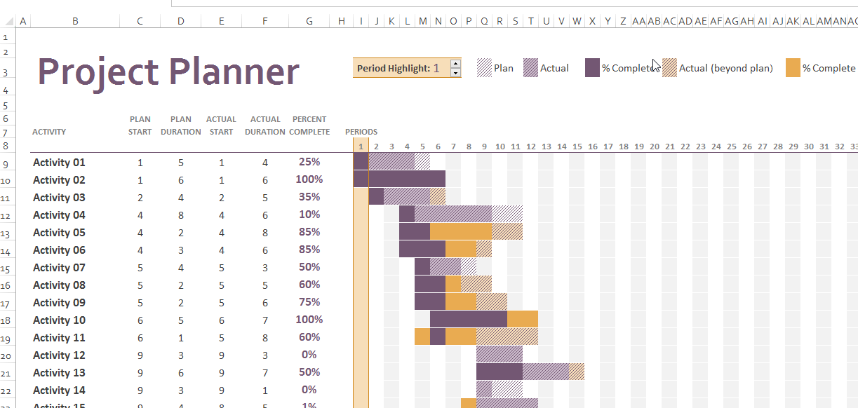
Use Microsoft Excel – Gantt Project Planner to help you create the Gantt Chart.
Each feature/function, sub feature/function should be structured and recorded as a monitored task in the project Gantt chart. The progress of each task should be updated and checked against plan. Plan it over the timeframe from Week 4 till Week 17. Use Appendix A (Page 11) as a guide for your timeline. For each task, the resource (i.e. name of student) should be attached too.
APPENDIX B.3 – System Design Document
Iterative Prototyping
Activity 3 – Design Document
The Design Document is used to capture your design considerations having considered the requirements stated earlier in the project proposal. The following is only a suggestion of what is needed for the report.
This document should follow the standard stated below. As a general guideline, your report (excluding the cover page and the appendixes) should not exceed 25 pages. The report should be prepared using one and a half line spacing.

Header and/or footer should be included to show at least the project name, the chapter name, the file name of the document and the page number. Each section/chapter should begin on a new page with an appropriate heading.

Cover Page
Document Title : _Design Document Submission for <Team Name – Group Number>__

Module Name : ITP271 Internet Application Development Project__

Submitted on : [Date]

Contents Page
This should list all the chapters/sections found in your report with their respective page number.

Introduction
[Write a high level introductory overview of your understanding of the project. This should be one to two three paragraphs which provide a description of the organization for which the site is intended, the purpose of the development of the web site and the purpose of the preparation of the design document. ]

Example:
Fast Book Services, founded in 2006, offers regular coach transportation in Singapore. Throughout the year, but primarily September to May, FASTBOOK runs charter services for recreational packages and heritage tours for young adults and senior citizens.

FASTBOOK has recognized that a website promoting their operation will help to enhance sales, increase customer loyalty and provide information to those who may not otherwise phone to ask for more information. Although the website will be primarily information based, FASTBOOK would like to consider the possibility of allowing customers to book tour packages online for events.

Site Structure
[This section deals with how all of your content will be organized within your site. In your functional specification, you have defined explicitly what the content is going to consist of and how it is to be organized or grouped. This section deals with breaking down the content in ways that will allow you to get your mind around all of the various elements and levels of detail. This is important as it helps to establish which navigational systems will best be employed to allow the user easy access to all areas of your site. Your site structure listing will detail each section and level of the site. A structure like this makes it very easy to see what the navigation requirements will be. For example, how will the user get to the package details section of Book Your Trip from the homepage? Within the structure listing, you may also want to summarize each section with a sentence or two explaining its role]

Example:

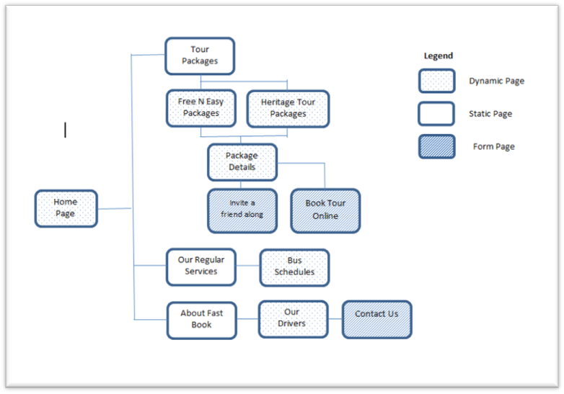

Visual Design
[In this section, you include wire frames which are non-graphical layouts of a proposed web site. A wireframe does not contain finished design elements as such, but does display where design elements will appear on the page. Wireframes allow your team members to do such things as:
- Test and refine navigation
- See how content lays out on the page
- Study and rapidly refine the user interface design of web forms and interactive elements
- Evaluate overall effectiveness of the page layout against usability best practices
- Determine web development/programming requirements]

You may use any online wireframe tool to quickly come up with the general layout and design of your website. You are to develop at the main look and feel of your website layout using the wireframe tools.
http://mashable.com/2010/07/15/wireframing-tools/
http://www.infragistics.com/products/indigo-studio

Place your wireframe design here:
Example:
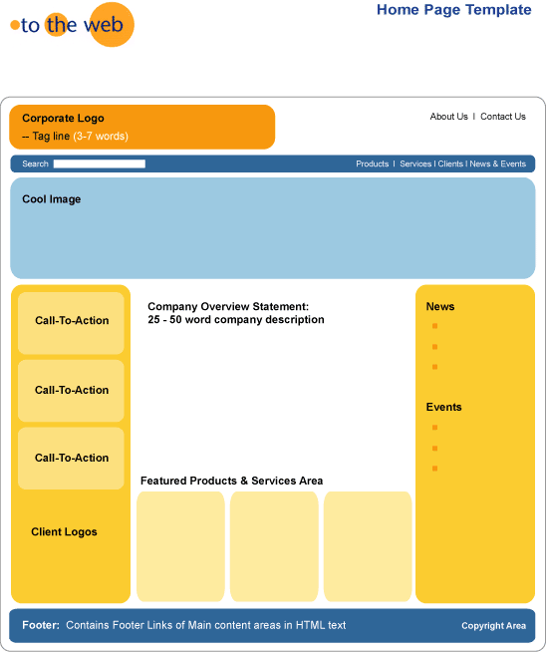

Database design
Include a diagram of your database Design here:

Example:

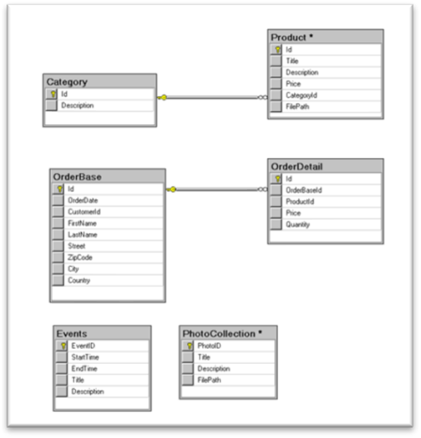

APPENDIX B.4.1 – Evaluation Worksheet
Testing & Evaluation

Activity 4– Evaluation
The Test mode is when you solicit feedback, about the prototypes you have created, from
your users and have another opportunity to gain empathy for the people you are designing for.
Testing is another opportunity to understand your user, but unlike your initial empathy mode,
you have now likely done more framing of the problem and created prototypes to test. Both
these things tend to focus the interaction with users, but don’t reduce your “testing” work to
asking whether or not people like your solution. Instead, continue to ask “Why?”, and focus on
what you can learn about the person and the problem as well as your potential solutions.

Use this sheet for Activity 4.
Evaluation Sheet
Evaluated by:_____________________ Evaluation for:_________________________ Date:_________________
Module to be evaluated: Example: Products Browsing Page
User Actions + Feedback:
Example:
1) The products page search button not visible. Maybe can place at top right hand corner like most websites.
2) After I login, there is no indication that I have already login when browsing the product page
3) The products displayed is not sortable by price or popularity
4) I cannot see back view of the product pictures… only 1 view – not user friendly. Usually by mouse over of product picture, I can see back view (in some websites).

Evaluation Sheet
Evaluated by:_____________________ Evaluation for:_________________________Date:_________________
Module to be evaluated:
User Actions + Feedback:

Evaluation Sheet
Evaluated by:_____________________ Evaluation for:_________________________Date:_________________
Module to be evaluated:

User Actions + Feedback::

APPENDIX B.4.2 – Project Test Plan
Use this part to complete your project test plan, that should be submitted as part of your final report. Each Student has to completed at least 2 test cases for his/her own modules that you have developed.
Project Test Plan Document

Test Description

<Examples:>
< Note : For each Use Case, test cases should use both valid and invalid data >
- Test Case 1: Login
Users have to perform a valid login using a user ID and password before accessing the site.
Test Case 1 : Login
Test Case Description : To verify login function
Pre-Condition:
- Web application (http://dts.com.sg/Login.aspx) is up and running.

Post Condition : None
Test Process Description
Test Case No. | Steps | Data | Expected Result | Actual Result
1.1 | Test with valid inputs  Enter valid user id and password, press “Login” button | User ID: user1  Password: password | main page displayed
1.2 | Test with invalid inputs (wrong password)  Enter invalid user id and password, press “Login” button | Username: user1  Password: 123456 | Pop up message: Incorrect password
1.3 | Test with invalid inputs (blank)  Enter invalid user id and password, press “Login” button | Username:  Password: | Remain in login page

- Test Case 2 : Create User Account
This test case will have an administrator create a User account.

Test Case 2 : Create Trainee
Test Case Description : To verify create new User function
Pre-Condition:
- Web application (http://dts.com.sg/Login.aspx) is up and running.
- Login success fully using an administrator account (User ID: nyp; Password: password)
- Click on User Tab.

Post Condition : None
Test Process Description
Test Case No. | Steps | Data | Expected Result | Actual Result
2.1 | Test with valid inputs  Click Add User link  Enter User ID and Name with your NRIC and name respectively, leaving the rest of the fields in their defaults.  Press ‘Submit” button | User ID: (your NRIC)  Name: (your name) | Pop up message: “User created successfully!”
2.2 | Test with duplicate User ID  Click Add User link  Enter User ID and Name with your NRIC and name respectively, leaving the rest of the fields in their defaults.  Press ‘Submit” button | User ID: (your NRIC)  Name: (your name) | Pop up message: “User ID already exists”  .
2.3 | Test with invalid inputs (invalid password)  Click Add User link  Enter User ID and Name with your NRIC (but with a different last alphabet) and name respectively.  Enter demo as password, leaving the rest of the fields in their defaults.  Press ‘Submit” button | User ID: (your NRIC but with different last alphabet)  Password: demo  Name: (your name) | Pop up message: Password must be more than 6 and less than 54 characters.

APPENDIX B.5 – Final Project Report
Reflection

This report should follow the standard stated below. As a general guideline, your report (excluding the cover page and the appendixes) should not exceed 20 pages. The report should be prepared using one and a half line spacing.

Header and/or footer should be included to show at least the project name, the chapter name, the file name of the document and the page number. Each section/chapter should begin on a new page with an appropriate heading. Name of student who has documented the section should appear at the header of the section.

You may include additional sections such as preface, acknowledgment, glossary of terms and symbols used, etc.

Recommended content outline:
i) Cover Page, this should reflect:
- Project Module Name, Document Title and Supervisor’s Name
- The Proposed Product Name
- The Project Team Number, Team Member’s Name and Admin No. (stating roles played, e.g., Group Leader, Secretary, etc.)
- The Latest Report Amendment Date
- Contents Page, this should list all the chapters/sections found in your report with their respective page number.
- Guides
  - User Guide (How to use the website as a user)
  - Installation Guide (How to install the website on a server)

- Project Test Plan (Appendix B.4.2)
- Reflection on what could have done better + Future Enhancements
- Conclusion

Appendix C (Grading Guidelines)

C1. Presentation

Element | Exemplary  Grade A | Proficient  Grade B | Partially Proficient  Grade C | Unsatisfactory  Grade D/F
Time Limit | Student's part of the presentation is within the allotted time limit. Whole group presentation is within 1 minute +/-of allotted time. | Student's part of the presentation is within 1 minute +/- of the allotted time limit. Whole group presentation is within 2 minutes +/- of allotted time. | Student's part of the presentation is within 2 minutes +/- of the allotted time limit. Whole group presentation is within 3-4 minutes +/- of allotted time. | Student's part of the presentation is too long or too short. Whole group presentation is 5 or more minutes above or below the allotted time.
Collaboration | Presenter worked as part of a team, providing effective transitions to next/previous speaker or making references to previous/next topics | Evidence of team work; transitions made to next/previous speaker or topics | Some evidence of team work; some transitions made to next/previous speaker or topics | No evidence of team work; no transitions made to next/previous speaker or topics
Organization | Strong and engaging introduction provides overview of presentation; presentation supports introduction; conclusion reinforces main points in memorable fashion. | Introduction provides overview of presentation; presentation supports introduction and ends with appropriate conclusion. | Some overview is given; connection between introduction and presentation is sometimes unclear; conclusion is limited. | Introduction does not give overview; organization is unclear, or presentation ends without conclusion.
Content / Preparedness | Content throughout the presentation is well-researched and presented succinctly; presenter is well-prepared and has obviously rehearsed. | Content is presented succinctly for the most part. Research and preparation are evident. | Content shows problems with research and succinct presentation; more preparation of the material is necessary. | Presentation of content is disjointed and incoherent; little evidence of preparation.
Evidence / Sources | Main ideas are presented with depth and effectively supported with facts, vivid details, and engaging examples. All key elements are included. Several sources (3 +) are used, mentioned, and cited. | Main ideas are supported with appropriate facts, examples, and details. One or two key elements may be missing; 2-3 sources are used, mentioned, and cited. | Some main ideas are supported with facts, examples, or details. More than two key elements are missing; only 1-2 sources are used OR mentioned/ cited inappropriately. | Main ideas are unclear; facts, examples, and details are lacking or fail to support ideas; presentation lacks several key elements or contains inaccuracies; no sources are used/mentioned/cited.
Speaking Skills / Voice | Poised, clear articulation/pronunciation; proper volume, speaking rate, and pauses. Presenter shows enthusiasm through emphasis. | Clear articulation/pronunciation but not as polished; volume, rate, and pauses mostly appropriate. Presenter's show of enthusiasm through emphasis is adequate. | Some mumbling; uneven rate and volume; little enthusiasm and emphasis | Volume too high or too low; rate too fast / slow; speaker seemed uninterested and used monotone; articulation/pronunciation often not clear
Physical Expression | Presenter communicates interest in topic with energy and poise, maintains eye contact with audience, uses facial expressions and gestures effectively; posture and appearance convey confidence and credibility. | Presenter communicates interest in topic, maintains eye contact for the most part, uses appropriate facial expressions, gestures, and posture. Appearance is appropriate. | Presenter has difficulty communicating interest in topic and maintaining eye contact. Some facial expressions, gestures, posture, or appearance may not be appropriate. | Presenter does not communicate interest in topic; maintains little eye contact; does not use facial expressions and gestures effectively; inappropriate posture and/or appearance.
Visuals | Visuals are attractive and effectively enhance the presentation; show considerable originality illustrate important points. | A few visuals are not attractive but all support the theme/content of the presentation. | All visuals are attractive but a few do not seem to support the theme/content of the presentation. | Visuals are unattractive AND detract from the content of the presentation.
Mechanics / Formatting | Background, font formats (colors, size, type), and graphics significantly enhance the presentation; no misspellings or grammatical errors. | Background, font formats, and graphics generally support the readability and content of the presentation; only 1-2 misspellings or grammatical errors | Some interference of background, font formats, or graphics with readability and content of the presentation; several misspellings or grammatical errors. | Background, font formats, or graphics make reading and understanding the material difficult OR detract from the presentation; many misspellings or grammatical errors.
Q&A Techniques | Presenter answers questions confidently and completely. | Presenter is able to respond to questions. | Presenter has difficulty responding to questions. | Presenter's answers to questions are incorrect or incomplete.

C2. Documentation & Reports

Element | Exemplary  Grade A | Proficient  Grade B | Partially Proficient  Grade C | Unsatisfactory  Grade D/F
Content | Goes beyond the requirements of the brief with additional detailed information | More than meet the requirement as prescribed in the brief | Meet most requirements as prescribed in the brief | Does not meet the requirements as prescribed in the brief
Content | Provides a fresh and balanced perspective on the topic. | Provides original ideas with a minimum of personal bias. | Provides one or two original ideas which include some personal bias. | Does not provide any original ideas and personal bias is obvious.
Content | Provides comprehensive insight, understanding, and reflective thought about the topic. | Provides a moderate amount of insight, understanding, and reflective thought about the topic. | Provides only minimal understanding, or reflective thought about the topic. | Provides no understanding or reflective thought about the topic.
Content | Content is technically of professional standards | Content has little technical errors | Content has considerable number of technical discrepancies or errors | Numerous technical discrepancies, exhibiting poor understanding of the subject matter
Content | Presents all information in a style that is appealing and appropriate for the intended audience. | Presents information in a style that is generally appropriate for the intended audience. | Presents information in a style that is often inappropriate for the intended audience. | Presents information in a disjointed, unpolished style which is inappropriate for the intended audience.
Organization | Uses a consistent organizational structure that includes grouping related information, defines specialized vocabulary and/or provides a table of contents. | Uses an organizational structure which groups some but not all, related information, defines specialized vocabulary and/or provides a table of contents. | Uses a loosely defined organizational structure which attempts to group similar items. | Fails to provide a consistent organizational structure, and information is difficult to locate.

C3. Project Delivery & Project Implementation

Element | Exemplary  Grade A | Proficient  Grade B | Partially Proficient  Grade C | Unsatisfactory  Grade D
Layout and Overall Design & Usability | Excellent and professional layout and bootstrap CSS adopted  Great Usability with intuitive design | Reasonably professional layout using bootstrap/CSS for styling  Good Usability | Simple CSS/bootstrap styling adopted  Reasonable usability | None/Poor CSS styling adopted and inconsistent layout
Database Design | Industry standard database design, advanced relationships and normalized. Zero data redundancy | Good database design with optimized relationships, minimized redundancy | Essential database design meeting the objective and functionality of the site | Disjointed and incomplete database design
Website Integration | Fully integrated, flawless linkage between different pages and modules. Optimised sharing of modules/functionality | Website is fully integrated and functioning without errors | Website is partially integrated | Website is not intergrated
Functionality | Fully functional, meet all requirements with additional functional technologies employed  Employed some intelligence in the functionality on top of the full CRUD ability | Mostly functional website. Meet all requirements  Dynamic data driven pages exist with ability to search, update, display or delete data | Few errors, mostly working functionality, but with some incomplete modules that are not functioning  Dynamic data driven pages exist with minimum functionality such as display, update, search | More than half of the functionality is unable to work.  50% integrated with the database and functioning
Deployment | Website is placed on a live server | Website is deployed on local server | Website is able to deploy, but not done | Website is unable to run
Technology | New Technologies adopted, deployed and functioning well
Innovativeness | Innovative new features that enhances user experiences, and business objectives | A few innovative and original functionality and features | Meet minimum requirements of website | Unoriginal and uninspiring functionality
Meet Business objectives | Website optimizes business operations, and goes above meeting business objectives, streamlined business processes | Website meet most business operations with some additional functionalities that enhances the business processes | Website met partial business objectives with essential operations working | Website does not meet business objectives

